**EXPT1**

Q describe motherboard?

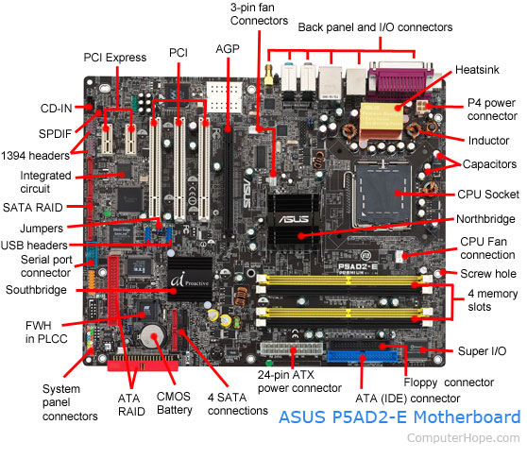

Q Distinguish between northbridge and southbridge?

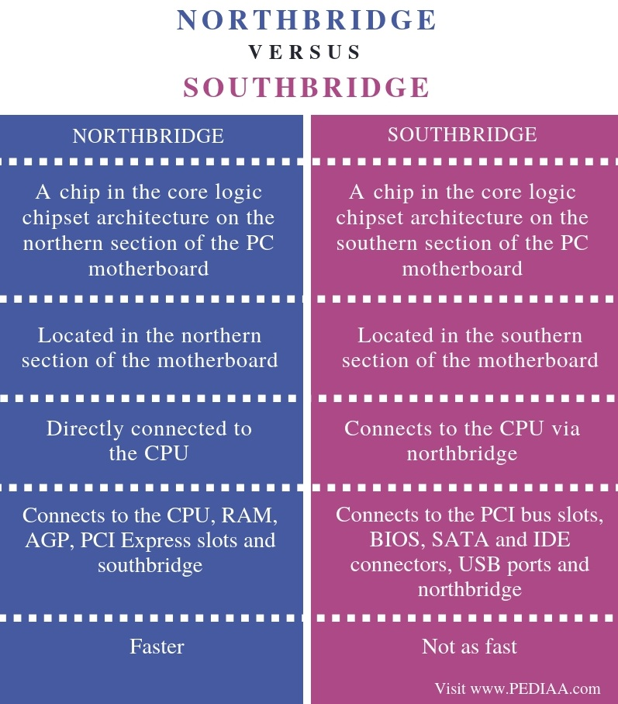

Conclusion:

The difference between northbridge and southbridge is that northbridge is a chip in the chipset of a motherboard that directly connects to the CPU while Southbridge is a chip in the chipset of a motherboard that does not directly connect to the CPU.

Q Components of the motherboard?

* **1. Mouse & keyboard:** Keyboard Connectors are two types basically. All PCs have a Key board port connected directly to the motherboard. The oldest, but still quite common type, is a special DIN, and most PCs until recently retained this style connector. The AT-style keyboard connector is quickly disappearing, being replaced by the smaller mini DIN PS/2-style keyboard connector.
* You can use an AT-style keyboard with a PS/2-style socket (or the other way around) by using a converter. Although the AT connector is unique in PCs, the PS/2-style mini-DIN is also used in more modern PCs for the mouse. Fortunately , most PCs that use the mini-DIN for both the keyboard and mouse clearly mark each mini-DIN socket as to its correct use. Some keyboards have a USB connection, but these are fairly rare compared to the PS/2 connection keyboards.
* **2. USB (Universal serial bus):**  USB is the General-purpose connection for PC. You can find USB versions of many different devices, such as mice, keyboards, scanners, cameras, and even printers. a USB connector's distinctive rectangular shape makes it easily recognizable.
* USB has a number of features that makes it particularly popular on PCs. First, USB devices are hot swappable. You can insert or remove them without restarting your system.
* **3. Parallel port:** Most printers use a special connector called a parallel port. Parallel port carry data on more than one wire, as opposed to the serial port, which uses only one wire. Parallel ports use a 25-pin female DB connector. Parallel ports are directly supported by the motherboard through a direct connection or through a dangle.
* **4. CPU Chip :** The *central processing unit,* also called the *microprocessor* performs all the calculations that take place inside a pc. CPUs come in Variety of shapes and sizes.
* Modern CPUs generate a lot of heat and thus require a cooling fan or heat sink. The cooling device (such as a cooling fan) is removable, although some CPU manufactures sell the CPU with a fan permanently attached.
* **5. RAM slots:** Random-Access Memory (RAM) stores programs and data currently being used by the CPU. RAM is measured in units called bytes. RAM has been packaged in many different ways. The most current package is called a 168-pin DIMM (Dual Inline Memory module).
* **6. Floppy controller:** The floppy drive connects to the computer via a 34-pin *ribbon cable,* which in turn connects to the motherboard. A *floppy controller* is one that is used to control the floppy drive.
* **7. IDE controller:** Industry standards define two common types of hard drives: EIDE and SCSI. Majority of the PCs use EIDE drives. SCSI drives show up in high end PCs such as network servers or graphical workstations. The EIDE drive connects to the hard drive via a 2-inch-wide, 40-pin ribbon cable, which in turn connects to the motherboard. *IDE controller* is responsible for controlling the hard drive.
* **8. PCI slot:** Intel introduced the *Peripheral component interconnect* bus protocol. The PCI bus is used to connect I/O devices (such as NIC or RAID controllers) to the main logic of the computer. PCI bus has replaced the ISA bus.
* **9. ISA slot:**  (Industry Standard Architecture) It is the standard architecture of the Expansion bus. Motherboard may contain some slots to connect ISA compatible cards.

**10. CMOS Battery:** To provide CMOS with the power when the computer is turned off all motherboards comes with a battery. These batteries mount on the motherboard in one of three ways: the obsolete external battery, the most common onboard battery, and built-in battery.

**11. AGP slot:**  If you have a modern motherboard, you will almost certainly notice a single connector that looks like a PCI slot, but is slightly shorter and usually brown. You also probably have a video card inserted into this slot. This is an *Advanced Graphics Port (AGP)* slot.

**12. CPU slot:** To install the CPU, just slide it straight down into the slot. Special notches in the slot make it impossible to install them incorrectly. So remember if it does not go easily, it is probably not correct. Be sure to plug in the CPU fan's power.

**13. Power supply plug in:** The Power supply, as its name implies, provides the necessary electrical power to make the pc operate. the power supply takes standard 110-V AC power and converts into 12-Volt, 5-Volt, and 3.3-Volt DC power.

Q Different types of connections?

Two basic network types are local-area networks (LANs) and wide-area networks (WANs). LANs connect computers and peripheral devices in a limited physical area, such as a business office, laboratory, or college campus, by means of links (wires, Ethernet cables, fibre optics, Wi-Fi) that transmit data rapidly.

WANs connect computers and smaller networks to larger networks over greater geographic areas, including different continents. They may link the computers by means of cables, optical fibres, or satellites, but their users commonly access the networks via a modem (a device that allows computers to communicate over telephone lines). The largest WAN is the Internet, a collection of networks and gateways linking billions of computer users on every continent.